Family Handbook

Safe Arrival app

School (506) 453-5420
Fax (506) 444-5113
New Maryland Elementary School
75 Clover Street
New Maryland, N.B.
E3C 1C5

Welcome

On behalf of the staff, Parent School Support Committee (PSSC) and Home and School Association of New Maryland Elementary School (NMES), I am very pleased to welcome all students and their families to our school community.

NMES opened in September of 1994 with 690 students in grades Kindergarten to Six. Enrollment ran between that number and 715 until the grade six was transferred to Middle School during the School District 18 re-organization in 1999.

We now host Kindergarten to Grade 5 with French Immersion offered as an option commencing at the Grade 1 level.

This handbook is intended to be used as an outline of our policies and procedures. There will be updates, revisions and additions. You are invited to refer to it frequently.
Code of Learning Code of Conduct
I am a Leader.
I use technology. I must be Safe
I am a creative thinker. I must cooperate
I am a global citizen. I must respect others
I compete with myself…
I collaborate with others.

Some interesting facts about NMES:

- We are one of the largest elementary schools in the province.

- Our Kindergarten classrooms were the first in New Brunswick public school system to be designed specifically for Kindergarten age students.

- The roof trusses over our gymnasium are the largest wooden trusses in Canada.

- Designated an NB Demonstration School and Microsoft Tour School

- Our mascot is a Bobcat

- Exemplary academic achievement.

I am Responsible….

We wish all students the greatest success as they continue with their learning and encourage all parents to stay involved with their child’s education.

Heather Hallett Laura Vail
Principal Vice Principal

School Vision

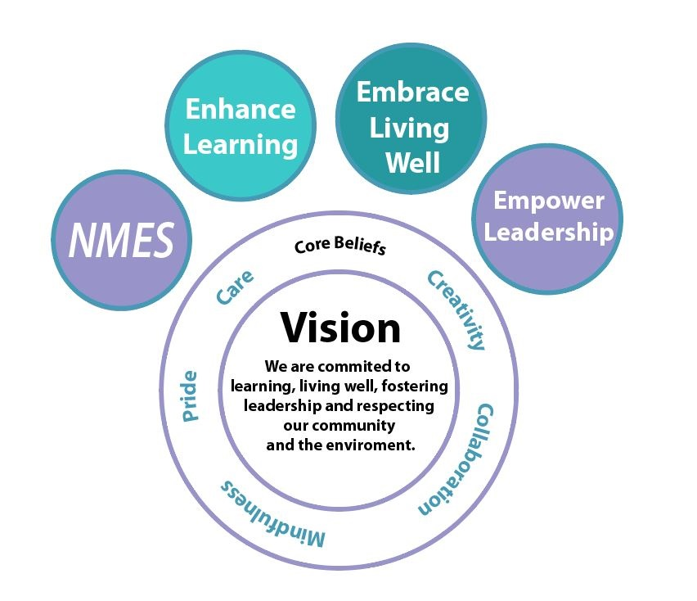

Leadership & Learning
Connect with Us

SAFETY

General
The school is responsible for and has jurisdiction over all students from the time they leave home (or their parent’s car) until they return home. All school rules are to be obeyed while walking to and from school, to and from the bus stop, and at the bus stop. Parents are expected to play a major monitoring role when students are between home and school.

When students are driven to school by private vehicle, they can be dropped off in the drop off lane no earlier than 7:50 a.m. as that is when supervision begins. If the driver must exit the car for even a short time, please park in one of the two parking lots on either side of the driveway. There are 3 accessible parking spaces in the left parking lot. Please do not park in the circle or drive in the bus lane.

Fire
NMES is equipped with the most modern fire detection & prevention system available. We have regular fire drills so our students and staff can be familiar with orderly evacuation procedures. Each class has a specific area on the school grounds to meet during a fire drill. There is an emergency plan in place with the district if students are unable to return to the school. The off-site evacuation location is the Faith Baptist Church.

Bus
The transportation system organizes annual bus evacuation drills for all students, usually in October.

Bicycles

Students are invited to drive bicycles to school under the following conditions:
- Their parents have given them permission to do so.
- They walk their bikes on the sidewalk from the crosswalk on Sprucewood Dr. to the bike racks when coming to school, and from the bike racks to the crosswalk on Sprucewood Dr. when leaving the school.
- They lock their bikes to the bike racks.
- They walk around (not through) the parking lot on their way to and from school.

Lost and Found
Please be sure to LABEL ALL YOUR CHILDREN’S BELONGINGS. There is a lost and found box in the entry way.

Telephone
The telephone in the main office is available for student use only in the case of illness or emergency. Permission is given by the classroom teacher.

Attendance:
School law requires compulsory attendance between the ages six and eighteen, unless sickness or a family crisis prevents it. There is no one at the school level that has the authority to excuse a student for any other reason. Teachers are required to record any absences and the reason for the absence.

SCHOOL HOURS, TARDINESS, ATTENDANCE, SAFE ARRIVAL

School Hours:
School yard supervision 7:50-8:15 am
Morning classes begin 8:15 am
Recess 10:05-10:25
Lunch 12:00-12:50
Dismissal K-2 2:00 pm
Dismissal Grades 3-5 3:15 pm
NOTE: WEDNESDAY CLASSES END AT 11:50AM FOR ALL GRADES

*Important: if your child will be leaving early, will be picked up by someone, or in some way the routine is changed, please send a written note with your child or e-mail the teacher.

Tardiness:

Being on time is an important life skill! In the case of tardiness, your child must report to the office and sign in. (If habitual tardiness occurs, the student may be required to make up the time missed).

Safe Arrival:
If your child is absent for the day or for multiple days or if your child will be late due to an appointment, please use the absence reporting system called SafeArrival.
SafeArrival enables you to report your child’s absence in advance using any of the three convenient methods below:
Please note: To sign up, please ensure you use the email address we have for you in PowerSchool.
Using your mobile device, download and install the free SchoolMessenger app from the Apple App Store or the Google Play Store (or from the links at https://go.schoolmessenger.com). The first time you use the app, select Sign Up to create your account. Select Attendance then Report an Absence.
Use the SafeArrival website, https//go.schoolmessenger.com. The first time you use the website, select Sign Up to create your account. Select Attendance then Report an Absence.
Call the toll-free number 1-833-294-4838 to report an absence using the automated phone system.

Wellness and Recreation
Wellness

As part of our school’s wellness philosophy, we have our students take part in outdoor activity breaks during our morning and noon recess times. Except under unusual circumstances, students who are too sick to take part in these outdoor sessions should be kept at home until their health improves.

Students are kept inside if it is raining or if the wind chill factor is colder than minus 20°C. If the temperature is between minus 12°C and minus 15°C the students may be in or out depending on the strength and direction of the wind. Students are always outside if it is minus 12°C or warmer.
Parents should provide:

- Appropriate clothing for the wet or cold conditions and instructions for it to be used; extra mittens during winter months. Younger students would benefit from having a change of clothes on site.
- Hats and/or sunscreen for hot and sunny days
- A water bottle daily.
Recreation
Intramural sports programs are offered in the gymnasium during recess and lunch breaks.

EMERGENCY NUMBERS

It is extremely important that we have an emergency telephone number in addition to the parents’ numbers, in the event that an emergency arises. It is also important to let us know if there is to be a change in routine if the school must close early. For this reason, parents are asked to complete the Student Data Collection Forms yearly.

SCHOOL CLOSURES

Full-day storm closures are announced early in the morning on the radio and on twitter. When school is closed during the day for any valid reason, the emergency plan indicated to the teachers early in the year by parents, is followed. You may also receive an e-mail from the school. NMES is part of “Zone 6”. Closures will be posted on the ASD-W website and twitter feed. @ASD-West as well as teacher Seesaw accounts.

INDOOR/OUTDOOR APPAREL

In order to maintain the cleanliness of the school, students are required to have indoor footwear. In most cases, sneakers with white or non-marking soles are the footwear of choice. One all-purpose indoor pair is sufficient and may be kept at school.

Proper outdoor clothing and footwear should be appropriate to the season and to daily weather conditions. Please check your child’s apparel before they leaves each day.

CURRICULUM

NMES offers a balanced curriculum of Math, Language Arts, Science, Social Studies, French, Health, Art, Music and Physical Education, as prescribed by the provincial Departments of Education. Language Arts and Math are assigned more time than the other subjects, and all subjects are often integrated with each other. Technology is used to support learning. Staff and students consume and create content in a blended learning environment.
We offer English Kindergarten, and Grades 1 -5 in either English or French Immersion. Students also have the option of entering the Late French Immersion program when they begin Grade 6 at the Middle School.

ASD-W provides information sessions annually for Kindergarten and Grade 5 parents to provide them with information to help decide whether to enroll their children in the English or French Immersion Program.

Our students take part in the Provincial Assessment as directed by the Department of Education. These occur in the spring of the year.

HOMEWORK: READING/STUDY HABITS

We know beyond a doubt that the involvement of parents in their children’s education is critical to success at school. Children should be encouraged to participate in many activities. However, they need to balance their extra-curricular actives with the demands of homework.

Support and interest shown by parents, influence student attitudes towards homework and study habits. If begun in the early grades, this should have a lifelong impact on your child. Some suggestions for parents are:
- Show interest and concern for your child’s efforts
- Provide a quiet, regular working area in your home for study
- Involve yourself as the “audience” for practice of spelling, math problems, reading, etc. It is very important to build your child’s confidence and self-esteem
- Assist your child in locating information and knowledge for homework projects
- READ ALOUD TO and WITH your children. The strongest factor in creating successful readers is their daily number of reading minutes.
- Contact your child’s teacher or the schools Resource teacher about how you can most effectively help your child succeed at school.

These are the suggested daily-homework time guidelines allotted per grade at NMES:
Kindergarten 5-10 Minutes (at Teachers
discretion)
Grade 1 10-15 minutes
Grade 2 15-20 minutes
Grade 3 15-20 minutes
Grade 4 30 minutes
Grade 5 30 minutes
NOTE: Reading and Project work is not necessarily included in these times.

Homework packages are not created to accommodate travel, sports etc.

Visitors
All visitors to NMES are requested to use doorbell and check in with the main office upon arrival. If you need to see your child/children they will be paged to meet you at the office.

Parent Volunteer Opportunities
Parents are encouraged to become involved in school activities. A sign-up notice listing the volunteer opportunities is sent home each September, and as the need arises throughout the school year. Some examples of opportunities are: Home and School, PSSC, safe Arrival, Library, fluoride program. There are also many one-time events that require volunteers.
Child Protection Policy
NMES follows the New Brunswick Child Protection Policy, commonly referred to as Policy 701. Volunteers in direct contact with students are required to have a criminal record check, vulnerable sector check, and a completed policy 701on file at the school.
http://701.nbed.nb.ca/toc-e.asp

School Exclusion Periods for Common Communicable Diseases

Diphtheria Four days after starting antibiotics
Measles Four days after appearance of rash
Mumps Nine days from appearance of rash
Rubella Four days after onset of rash
Whooping Five days after starting
Cough antibiotics
Chicken Pox Five days after onset of rash
Fifth Disease None
Hepatitis A One week after onset of jaundice
Mononucleosis None
Strep Throat 24 hrs. after starting antibiotics
Impetigo 24 hrs. after starting antibiotics
Scarlet Fever 24 hrs. after starting antibiotics
Scabies 24 hrs. after starting treatment
Pediculosis (Lice) Until treatment is finished
(demonstrated by absence of nits)
Pink eye 24 hrs. after starting treatment
Ringworm None

When should my child stay home?

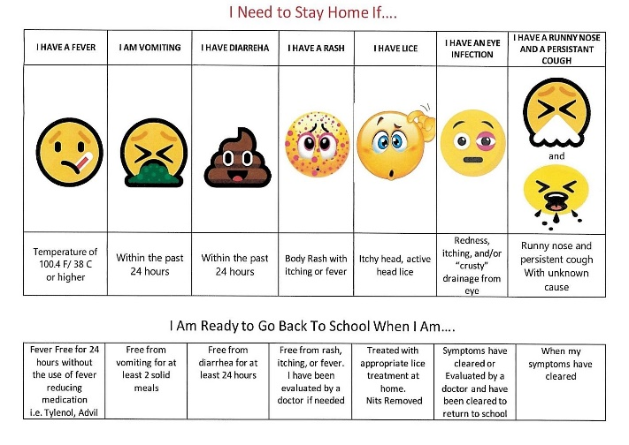

Lice
Every year we encounter cases of head lice.
If your child becomes infected, please notify the school or the classroom teacher. Please note that all evidence of infestation must be eliminated before the child returns to school

Specialists
New Maryland Elementary School has specialist teachers as assigned by ASD-W. At present these include:
Three Resource teachers: to provide assistance and consultation for classroom teachers in assessment, planning, instruction and evaluation for students.
Music: Teaching music 30 minutes per week for each class K-5.
Physical Education: Teaching grades K-5 three times per week. Students require appropriate clothing.
School Counciler: Works with all students and parents to help guide students' academic, behavioral and social growth.

School Supplies
A list of supplies for students is provided at each grade level. At NMES classroom teachers ask for a fee. This allows them to order supplies in bulk and reduces shopping time for families.

Field Trips and Co-curricular Activities
Parental permission is required for all class outing. In September, each parent is asked to sign a General Permission Slip to cover bus trips throughout the year. The details of each trip will be sent home by the classroom teacher, in writing, in advance of the trip.

Dispensing of Medication/Allergies
Parents are to complete a Parent Authorization form in the office before any medication can be given to their child by a teacher at school. Depending on the situation, a Physician’s Statement form may need to be completed.
All children who have an Epi-pen are identified at the main office, and their Epi-pens are kept with them.
Children with special health needs are encouraged to wear Medical Alert bracelets.
Due to food allergies, we request that you do not include nuts, peanuts or peanut butter in student lunches.

Special Needs Accommodations
NMES is wheelchair accessible with ramps and larger washrooms located in each area of the school. Our school based education support services team monitors and supports the requirements of policy 704; Health Support Services

Library
All classes use the library weekly. During library time they enjoy “read alouds”, book discussion and time to browse the available titles. Students are invited to borrow books for pleasure reading and research.

Dogs and large pets: Please leave pets at home. Dismissal times involve many students and adults.

Parent School Support Committee

(PSSC) is made up of volunteer parents of NMES students, as well as and appointed community member and teacher representative. The PSSC is expected to address “broad issues related to the education of all children in the school, with the goal of enhancing student learning.”

The major role of the PSSC is “to give advice regarding the establishment, implementation and monitoring of the school improvement plan.” In this capacity, the PSSC is meant to advise the principal on: “aspects of learning that need to be improved; the priority of those identified areas; and strategies/actions that focus on those areas chosen to improve learning.”
Regular monthly meetings are held at the school. These evening meetings are open to the public, and you are encouraged to attend. Contact the school for the tie and date.

Home and School Association
The Home and School Association organizes all fund-raising activities in the school, and sponsor many programs and events which benefit the school. Initiatives such as the purchase and installation of playground equipment, purchase of technology hardware, subsidizing the cost of special visitors and filed trips all benefit from the sponsorship of the Association. Funds are raised through events such as spell-a-thons, school logo clothing sales and silent auctions. Their biggest event of the year is the organization and facilitation of the Fall Frolic in October. Although money is raised at this event. The primary objective is to promote and sustain connections between home, school and community. The Association meets monthly, the first Tuesday of every month. All parents are invited to join the meetings and become involved.
Report Cards and Conferences

As per the ASD-W schedule, NMES sends out report cards in December, April and
June. The December and April reports are followed by Parent-Teacher conferences. Parents can request a conference at any time during the year.
Any concerns relating to your child should be voiced with the classroom teacher. If the concern persists, it should then be brought to the attention of the school administration. Any unresolved matters can then be taken to the District Office.

Cafeteria
All NMES students have the option of going home for lunch, bringing a bag lunch, buying lunch at the cafeteria (Chartwells), or any combination of these. Special dinners are served on occasions. You can follow our cafeteria on Facebook: New Maryland Elementary School Cafeteria. Meals may be pre-purchased at https://nutrislice.com

Yearbook
The NMES Yearbook is available for purchase near the end of the school year.

School Buses
ASD-W publishes the bus routes and schedule in August of each year. Questions pertaining to schedules, stops, etc. should be addressed to the Transportation Department at ASD-W. A district-wide behavioral code related to students on buses is published as well. School bus rules are stresses by the school and should be reviewed by parents.
Link: asdwbp.nbed.nb.ca/TransportationEligibility
Please note: after school busing changes require 24 hours notice to the school and cannot accommodate social or sporting events. District Office line 506-453-5454.

Toys and invitations
- Invitations for private activities will not be distributed at school. A class Contact List will be distributed to all parents within each classroom (with individual parental permission) including student name, phone number and/or email address.
- Non-essential items will not be permitted at school. These include all items that are not required for regular school activities such as all toys, electronic games, playthings

School Cash Online:

-Create Your Profile at:
https://anglophonewest.schoolcashonline.com

-Confirm your e-mail

-Add a student

Payment methods:
Credit card eCheck myWallett

