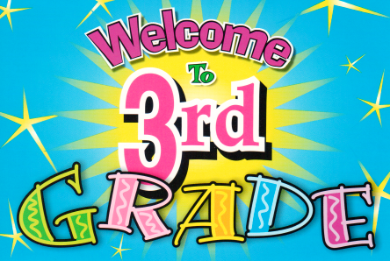

**June 2024**

**Welcome to Grade 3 for the 2024-25 School Year!**

**A $55.00 Student Fee will be collected at the beginning of school. ASD-W’s preferred form of payment is through SchoolCash Online. You are able to register – a simple task that takes less than 2 minutes by visiting** [**https://www.schoolcashonline.com/**](https://www.schoolcashonline.com/) **or visiting our website at** [**http://web1.nbed.nb.ca/sites/ASD-W/NMES/Pages/default.aspx**](http://web1.nbed.nb.ca/sites/ASD-W/NMES/Pages/default.aspx) **and navigating your way to the School Cash Online on the right hand side of the screen.**

**In addition, please provide the following items:**

* **A sturdy pair of sneakers (if the laces tie, ensure your child is efficient at tying the laces themselves and that the laces are NOT too long and pose a tripping hazard)**
* **A lunchbox**
* **A backpack**
* **A water bottle**
* **1 package of Kleenex**
* **A pair of headphones to use with the laptops**

**Please have a couple extra pairs of socks and a change of clothes in your child’s backpack in case of emergencies.**

**Have a safe and happy summer. We’ll see you in September.😊**

**Grade 3 English Teachers**