June 2024

**New Maryland Elementary School**

**School Supplies for Grade 5 English/Intensive French & French Immersion**

**2024-2025**

Hello students and families! Welcome to Grade 5!!

In September, a fee of $55.00 will be collected from each student to cover the cost of school supplies for the academic year. ASD-W’s preferred form of payment is through School Cash Online. You are able to register – a simple task that takes less than 2 minutes, by visiting: [SchoolCashOnline.com: Welcome](https://schoolcashonline.com/) or visiting our school website at <https://nmes.nbed.ca/> and navigating your way to the ‘Current Students’ tab, and then clicking on ‘Student Fees’. Fees are usually set to go live on School Cash Online the last week of August.

The only items your child will need to bring with them in September include:

* A pair on indoor sneakers (non-marking soles please)
* A box of facial tissues
* A pack of dry erase markers

Thank you! We look forward to seeing you in September.

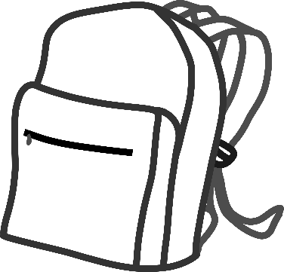

From, the Grade 5 Teachers.